SPECIALS
London Fog Pronut  Gluten-Free  *Contains dairy and tree nuts | 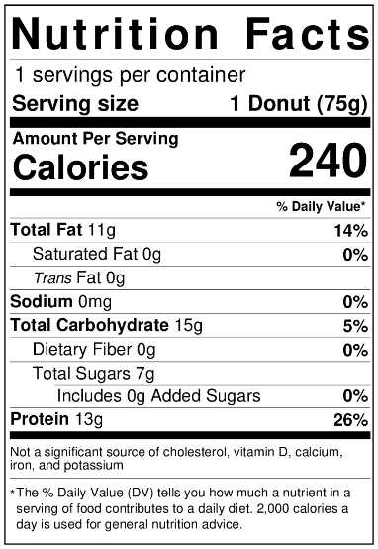 | Cranberry Orange Muffin  Gluten-Free  *Contains dairy and tree nuts | 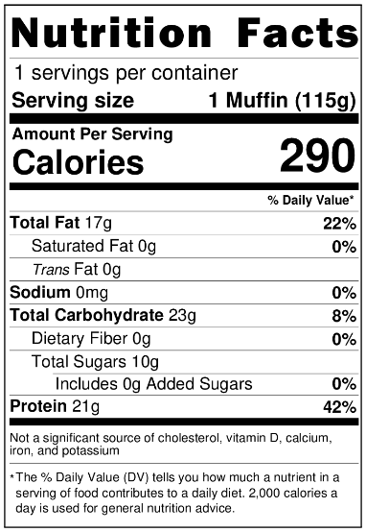
Pecan Pie Muffin  Gluten-Free  *Contains dairy and tree nuts |  | Peanut Butter Cup Brownies  Gluten-Free  *Contains dairy and tree nuts and peanuts | 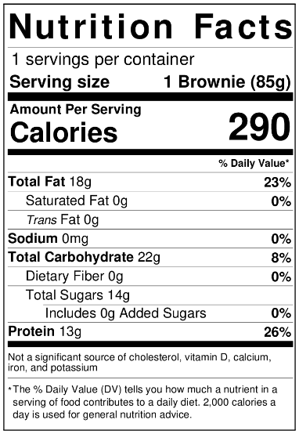
Gingersnap Cookie  Gluten-Free  Vegan  *Contains tree nuts | 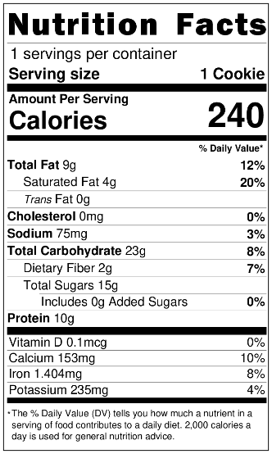

CLASSIC PRONUTS
Blueberry Basil  Gluten-Free  *Contains dairy and tree nuts | 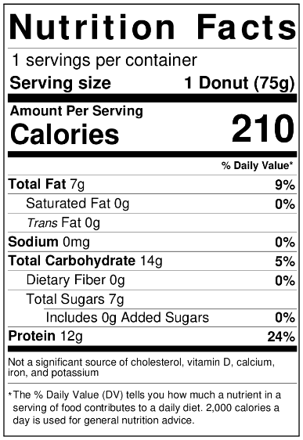 | Carrot Cake  Gluten-Free  *Contains dairy and tree nuts | 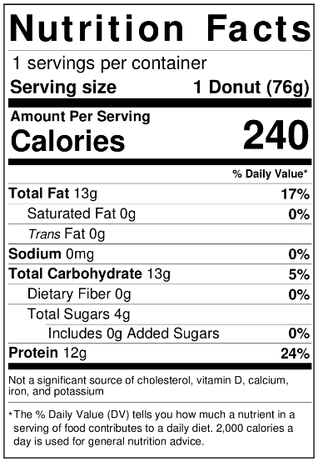
Chocolate  Gluten- Free  *Contains dairy and tree nuts | 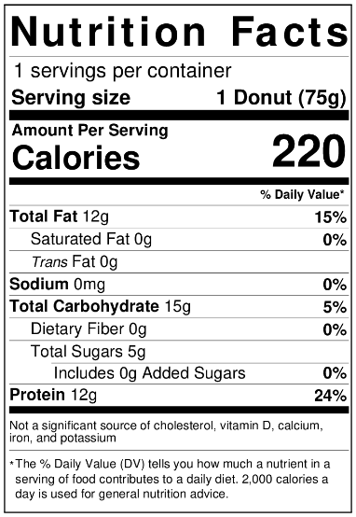 | Cinnamon Sugar  Gluten- Free  *Contains dairy and tree nuts | 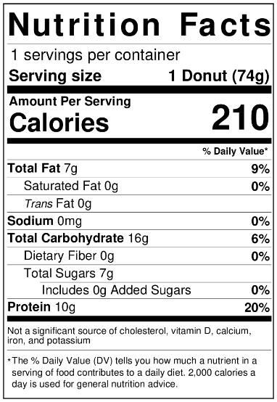
Coconut  Gluten- Free  Keto-Friendly  *Contains dairy and tree nuts | 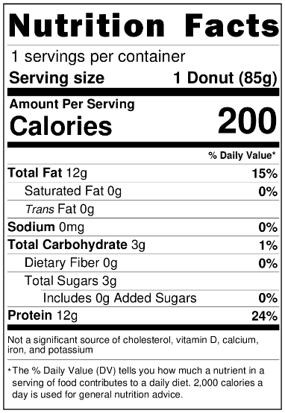 | Cookies & Cream  Gluten- Free  *Contains dairy and tree nuts | 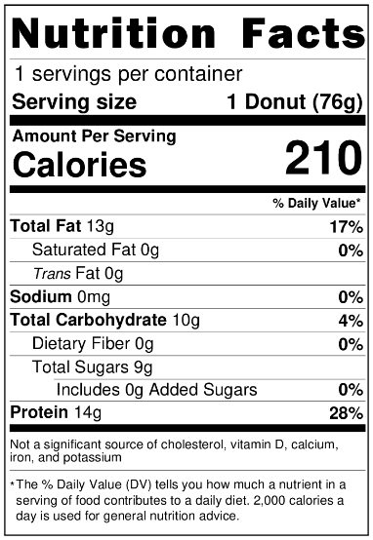
Espresso  Gluten- Free  *Contains dairy and tree nuts | 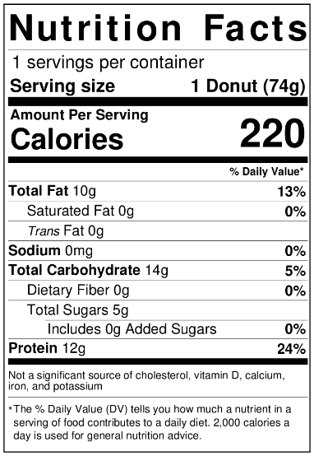 | Mango Cardamom  Gluten- Free  *Contains dairy and tree nuts | 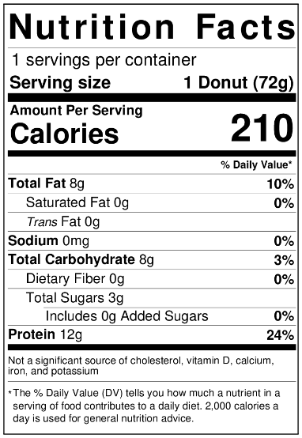
Matcha  Gluten- Free  *Contains dairy and tree nuts | 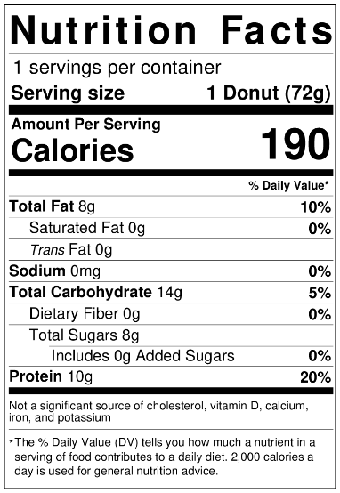 | Mint Chocolate  Gluten- Free  *Contains dairy and tree nuts | 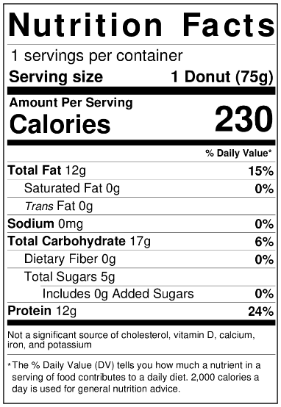
Peanut Butter  Gluten- Free  *Contains dairy, peanuts and tree nuts | 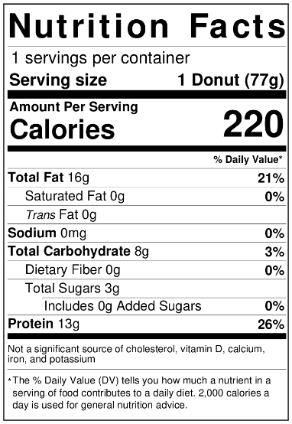 | Peanut Butter Cup  Gluten- Free  *Contains dairy, peanuts and tree nuts | 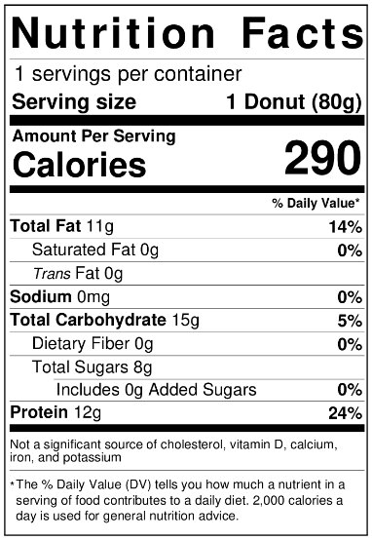
The PRONUT  Gluten- Free  *Contains dairy, peanuts and tree nuts | 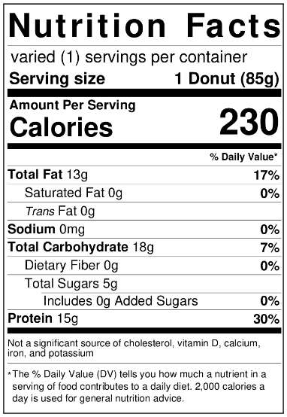 | Pumpkin Spice  Gluten- Free  Keto-Friendly  *Contains dairy and tree nuts | 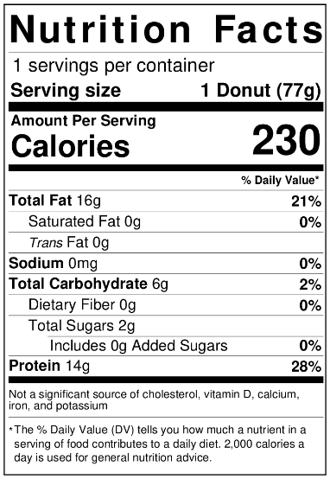
Red Velvet  Gluten- Free  *Contains dairy and tree nuts | 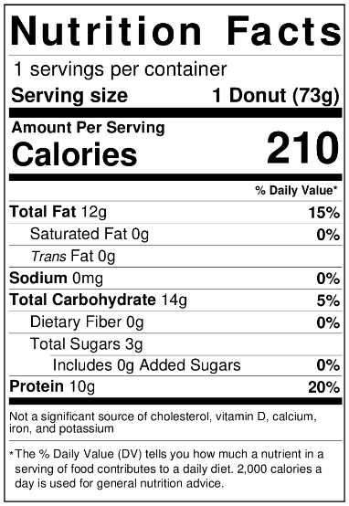 | Strawberries & Cream  Gluten- Free  *Contains dairy and tree nuts | 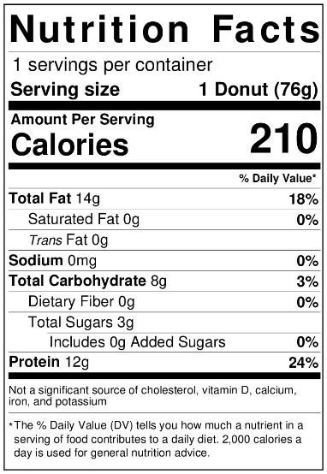
Ube Pistachio  Gluten- Free  Keto-Friendly  *Contains dairy and tree nuts | 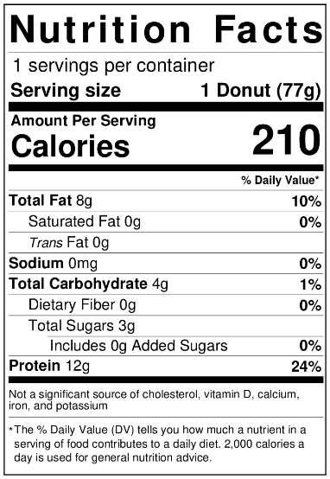 | Vanilla Glaze  Gluten- Free  *Contains dairy and tree nuts | 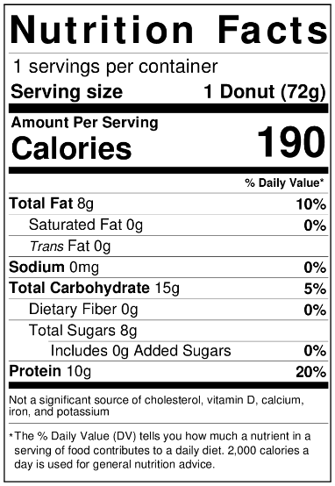
London Fog  Gluten- Free  *Contains dairy and tree nuts |  | Ferrero  Gluten- Free  *Contains dairy and tree nuts | 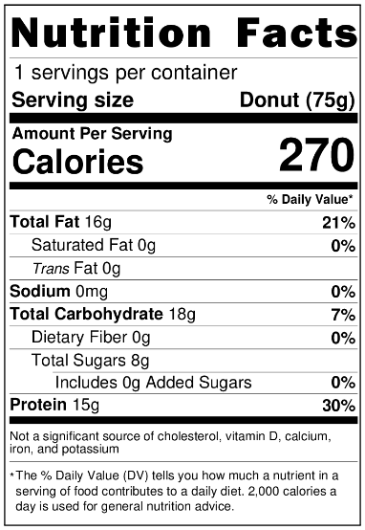

VEGAN PRONUTS
Blueberry Basil  Gluten- Free  *Contains peanuts and tree nuts | 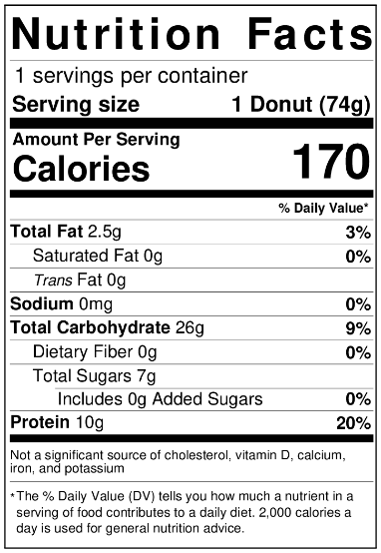 | Carrot Cake  Gluten- Free  *Contains peanuts and tree nuts | 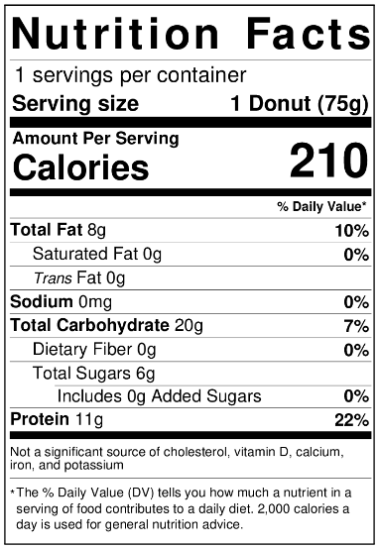
Chocolate  Gluten- Free  *Contains peanuts and tree nuts | 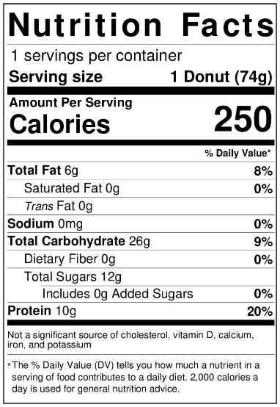 | Cinnamon Sugar  Gluten- Free  *Contains peanuts and tree nuts | 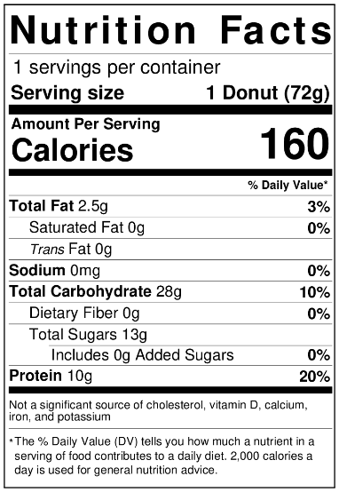
Cookies & Cream  Gluten- Free  *Contains peanuts and tree nuts | 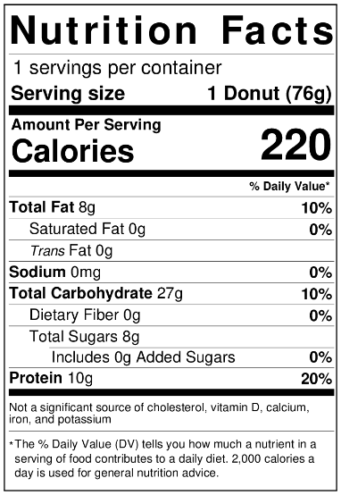 | Matcha  Gluten- Free  *Contains peanuts and tree nuts | 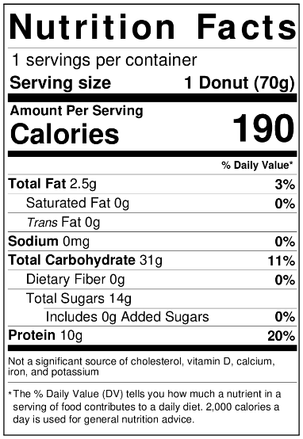
Peanut Butter  Gluten- Free  *Contains peanuts and tree nuts | 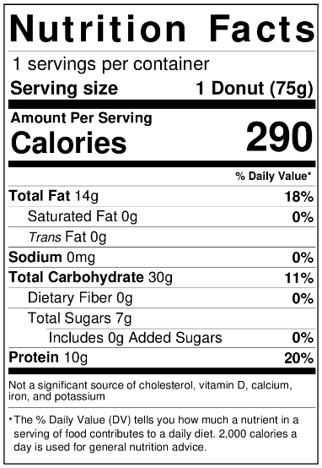 | Peanut Butter Cup  Gluten- Free  *Contains peanuts and tree nuts
The PRONUT  Gluten- Free  *Contains peanuts and tree nuts | 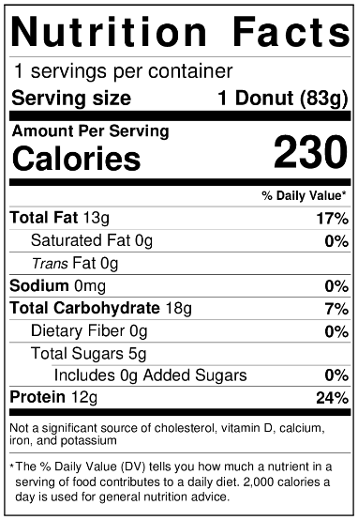 | Red Velvet  Gluten- Free  *Contains peanuts and tree nuts | 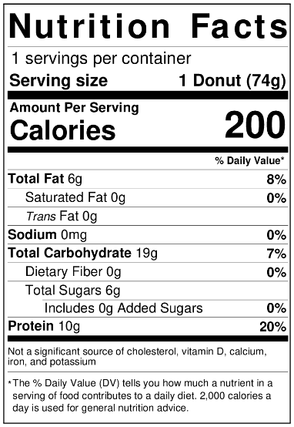

PROTEIN COOKIES
The PRONUT Cookie  Vegan  Gluten- Free  *Contains peanuts and tree nuts | 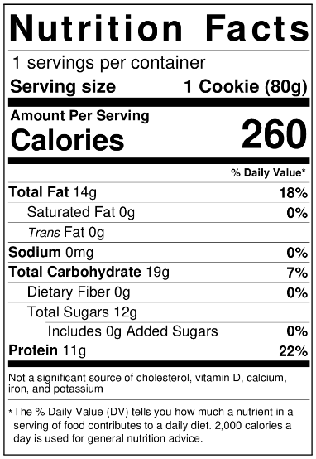 | Cookies & Cream  Vegan  Gluten- Free  *Contains peanuts and tree nuts | 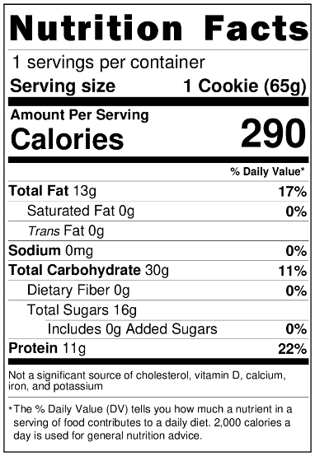

PROTEIN CUPCAKES
Red Velvet  Gluten- Free  *Contains dairy and tree nuts | 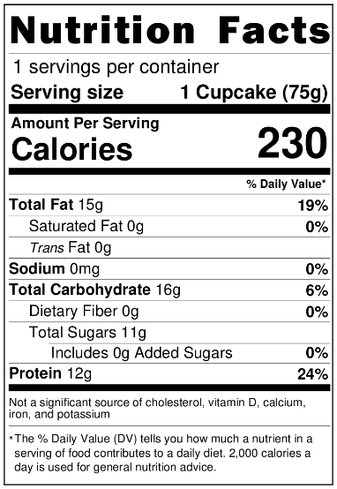 | Peanut Butter Chocolate  Gluten- Free  *Contains dairy and tree nuts | 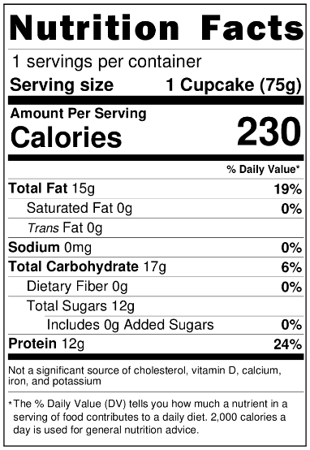
Carrot Cake
Gluten- Free

*Contains dairy and tree nuts

PROTEIN MUFFINS
Apple Cinnamon  Crumble Gluten-Free  *Contains dairy and tree nuts | 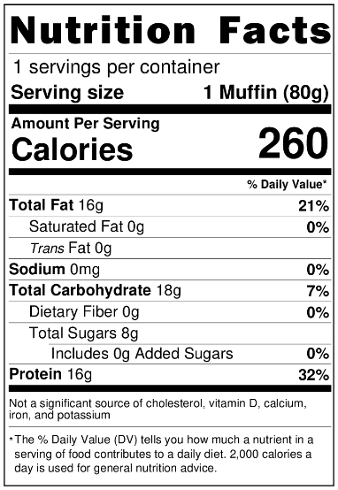 | Blueberry  Gluten-Free  *Contains dairy and tree nuts | 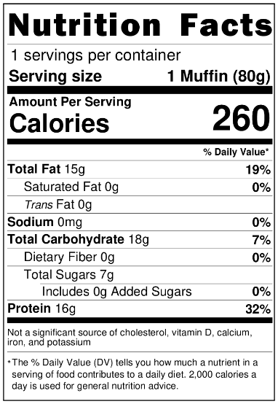
Double Dark Chocolate  Gluten-Free  *Contains dairy and tree nuts | 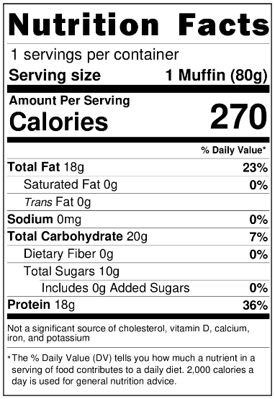 | Pistachio Muffin  Gluten-Free  *Contains dairy and tree nuts | 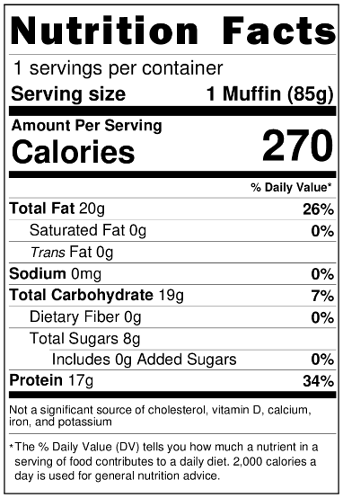

PROTEIN BROWNIES
Dark Chocolate Brownie  Gluten-Free  *Contains tree nuts and dairy |  | Walnut Brownie  Gluten-Free  *Contains tree nuts and dairy | 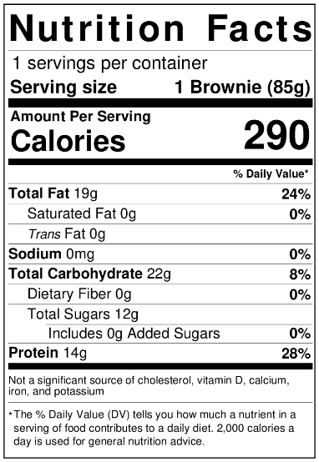
PROTEIN SMOOTHIES
Cookies & Cream  Gluten-Free  *Contains dairy | 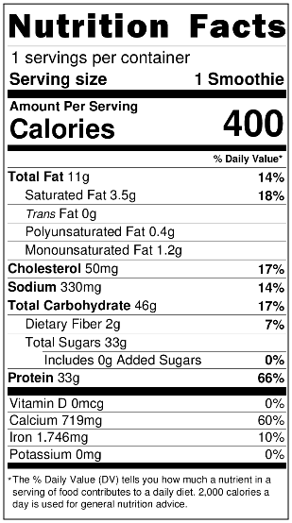 | Mango  Gluten-Free  *Contains dairy | 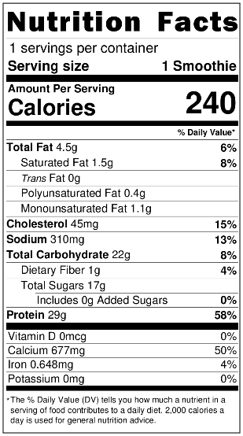
The PRONUT  Gluten-Free  *Contains tree nuts and dairy | 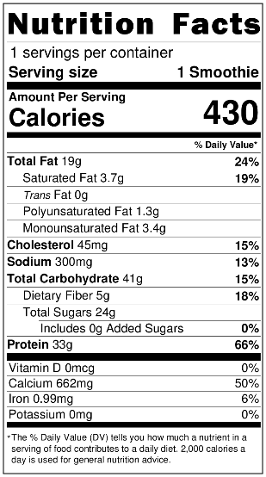 | Berry Explosion  Gluten-Free  *Contains dairy | 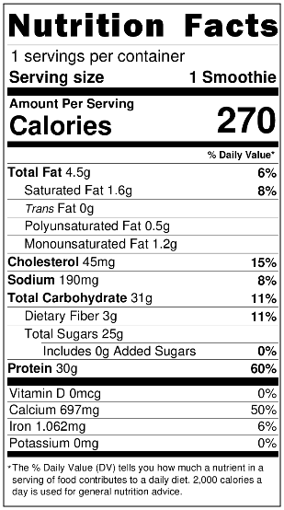
Pumpkin Spice  Gluten-Free  *Contains dairy and tree nuts | 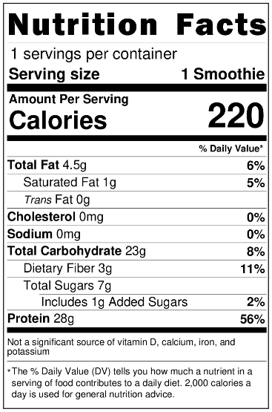 | The PROFFEE  Gluten-Free  *Contains dairy

